**Case Study- Shark Attack**

**Batch-Adv.Ex/EK/15 May/10-1 pm/**

**Name- Mukesh Ashok Mane**

1. Show the count of attacks by country -- which 3 countries had the highest number of reported attacks over the past 5 years (2012-2016)? During this period, what % of reported attacks occurred in Spain? Then use a PivotChart to visualize this view as a Clustered Bar Chart.

**Year Wise Attack :-**

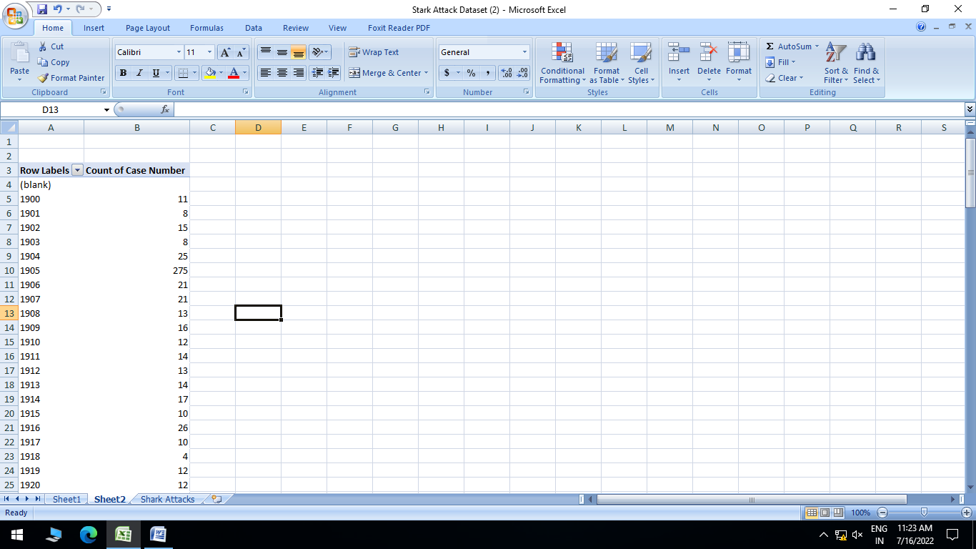

**> Count of Countrywise attack:-**

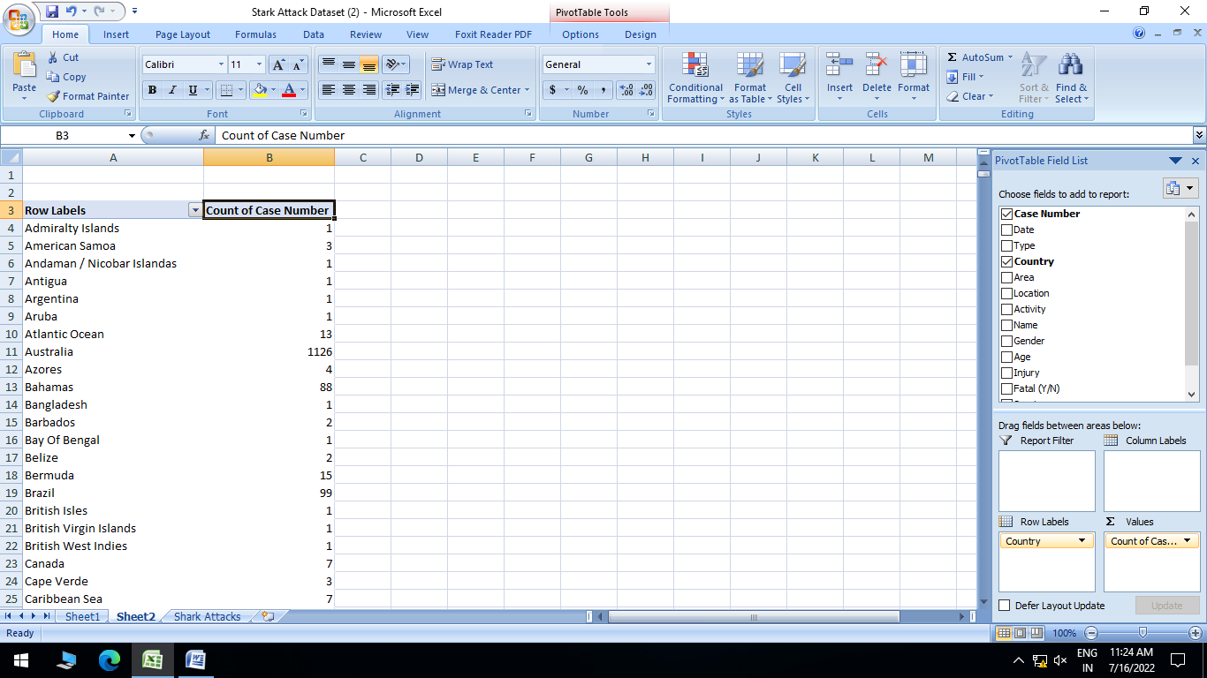

**> which 3 countries had the highest number of reported attacks over the past 5 years (2012-2016):-**

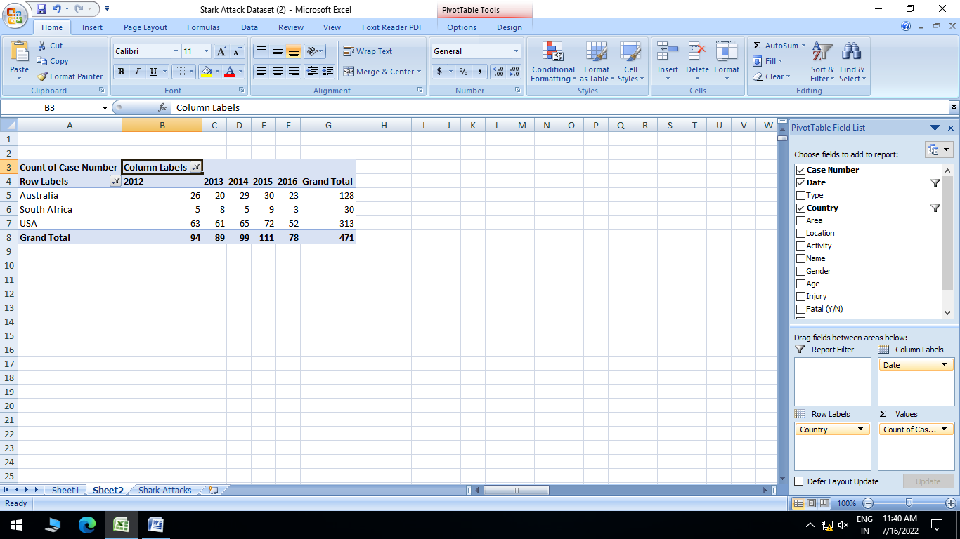

**>** **During this period, what % of reported attacks occurred in Spain?:-**

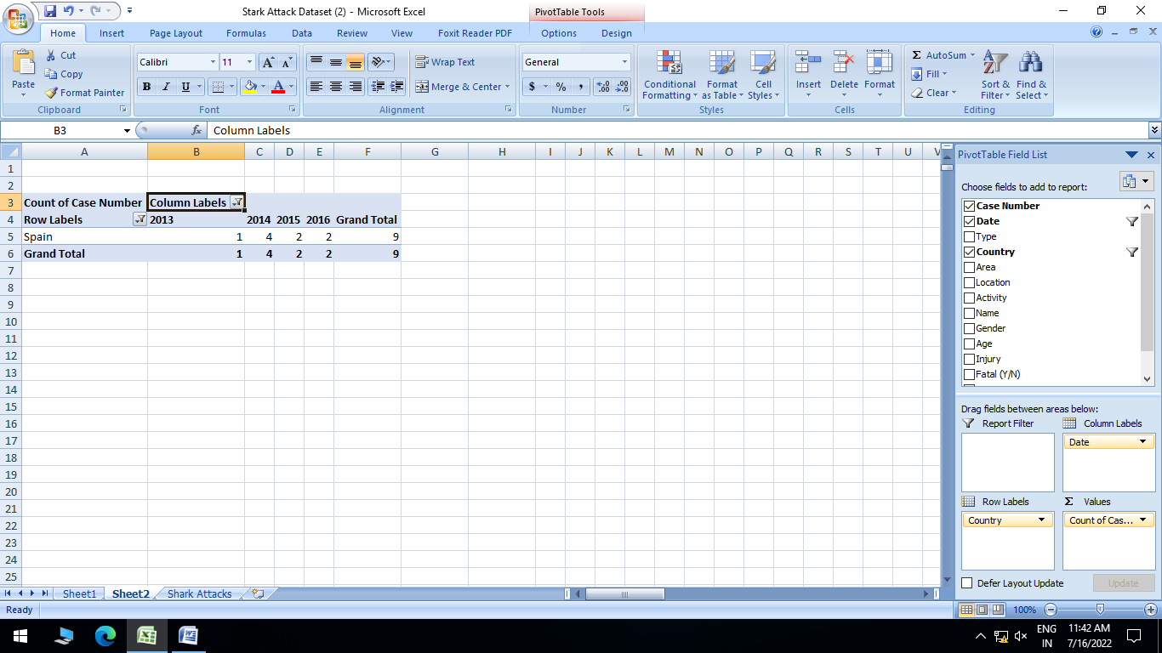

>**Then use a PivotChart to visualize this view as a Clustered Bar Chart:-**

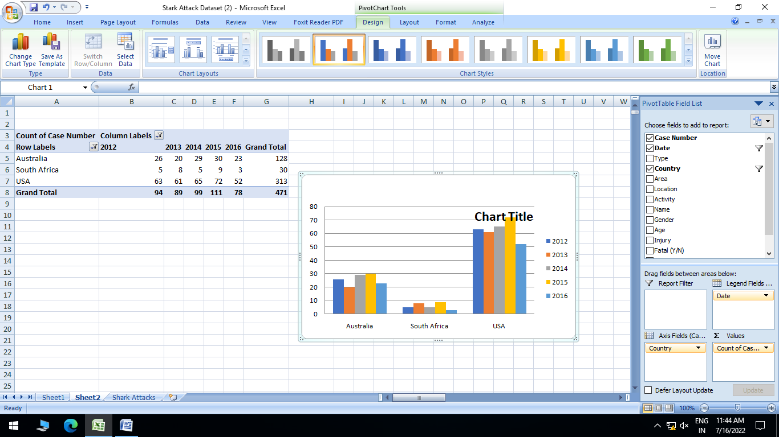

Q2. **Drag the "Area" field to the PivotTable row labels, change the Report Layout to Outline, and filter to show the top 5 areas by count of Case Number, by country. Where in South Africa were shark attacks most frequently reported over the past 5 years?**

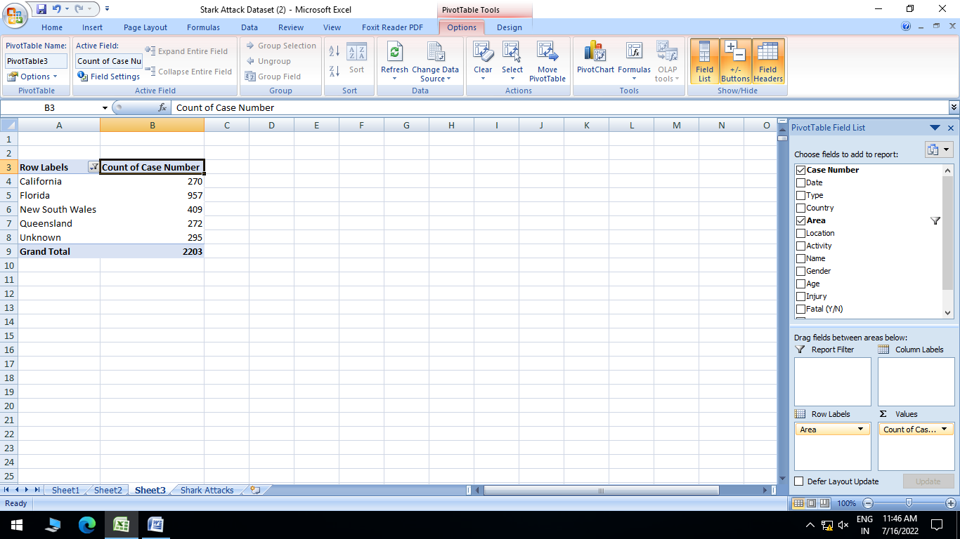

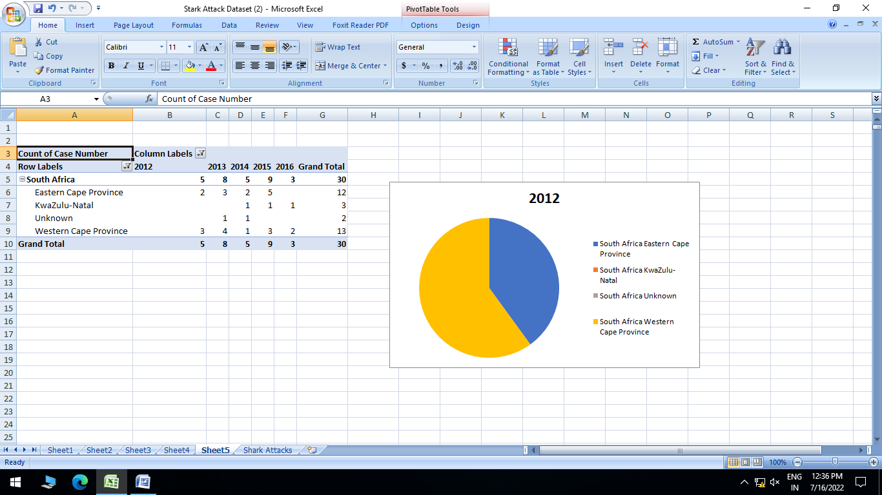

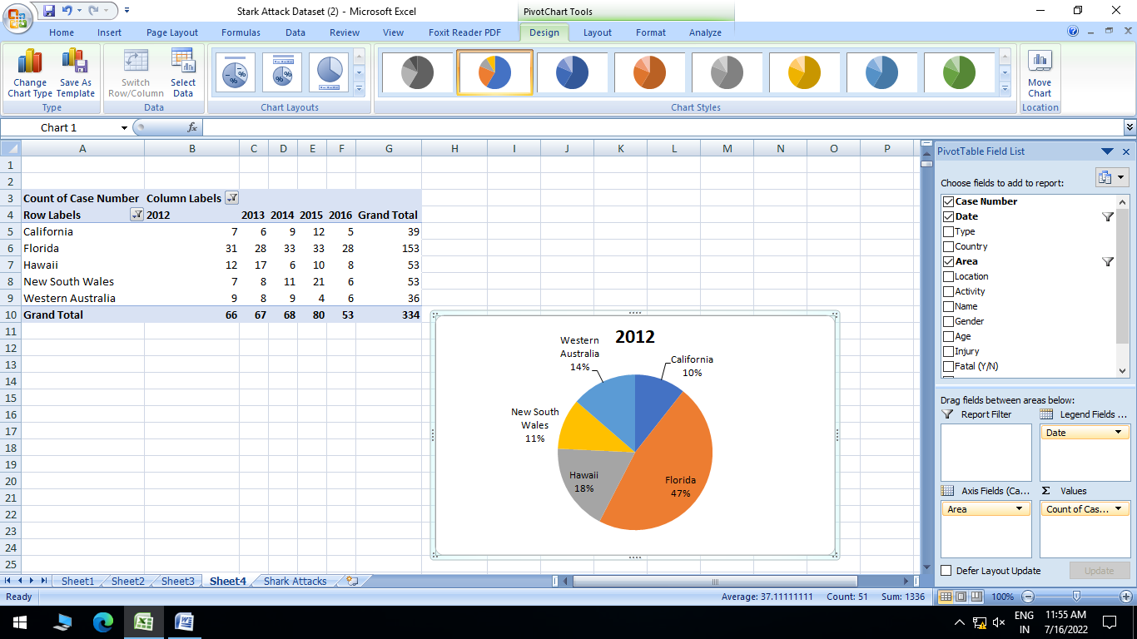

**Q.3-Replace "Area" with "Type" and show the Count of Case Number values as % of Parent Total for each country. What % of attacks in New Zealand were unprovoked? How many cases**

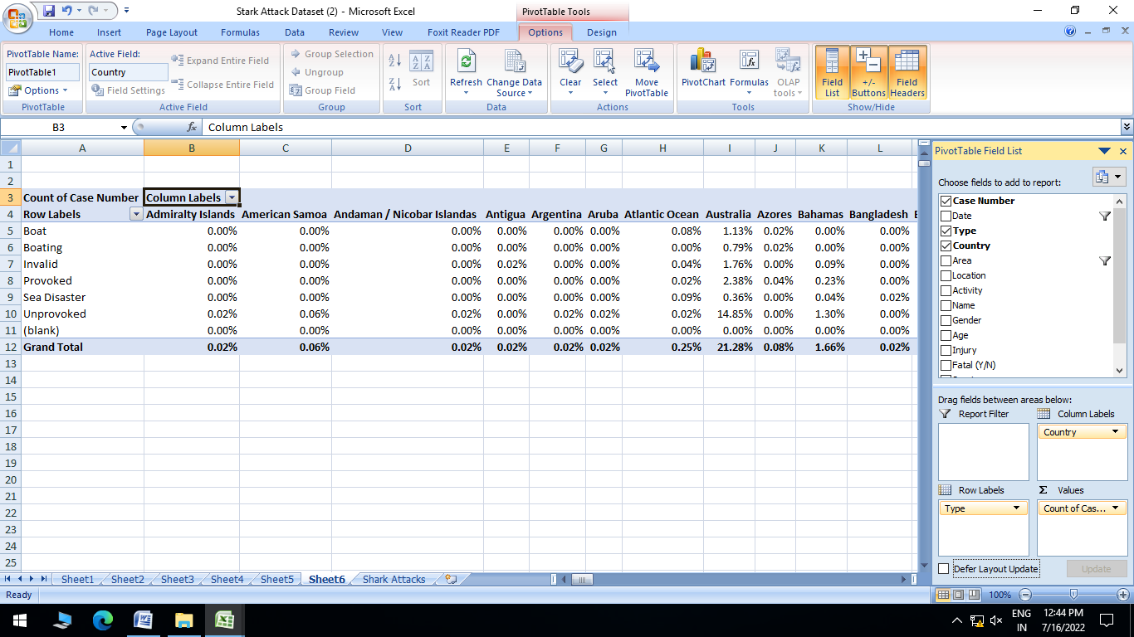

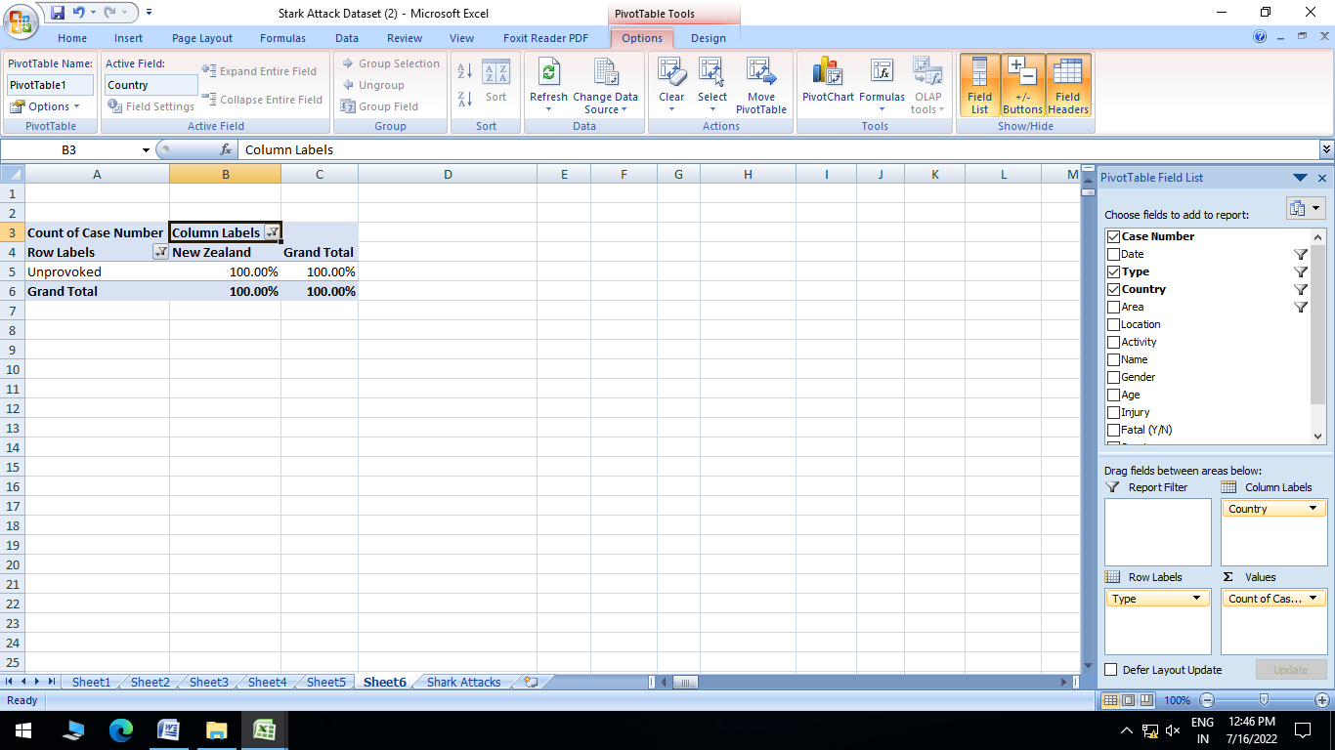

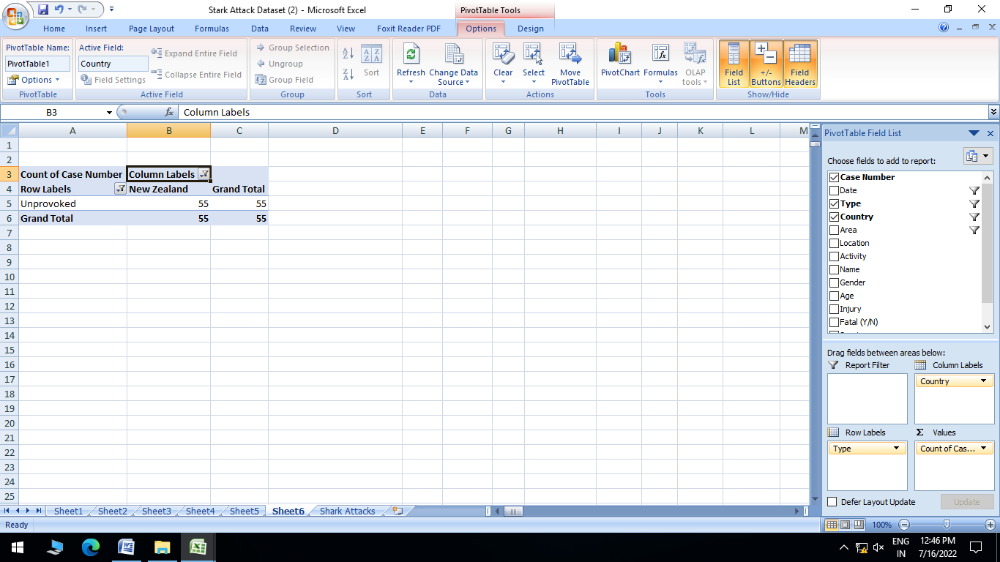

**Q.4-Filter the Pivot for the USA only, and create a PivotChart to show the count of shark attacks by "Area". Use a column chart, and hide all field buttons. Try changing the chart type to a Donut or Bar Chart instead.**

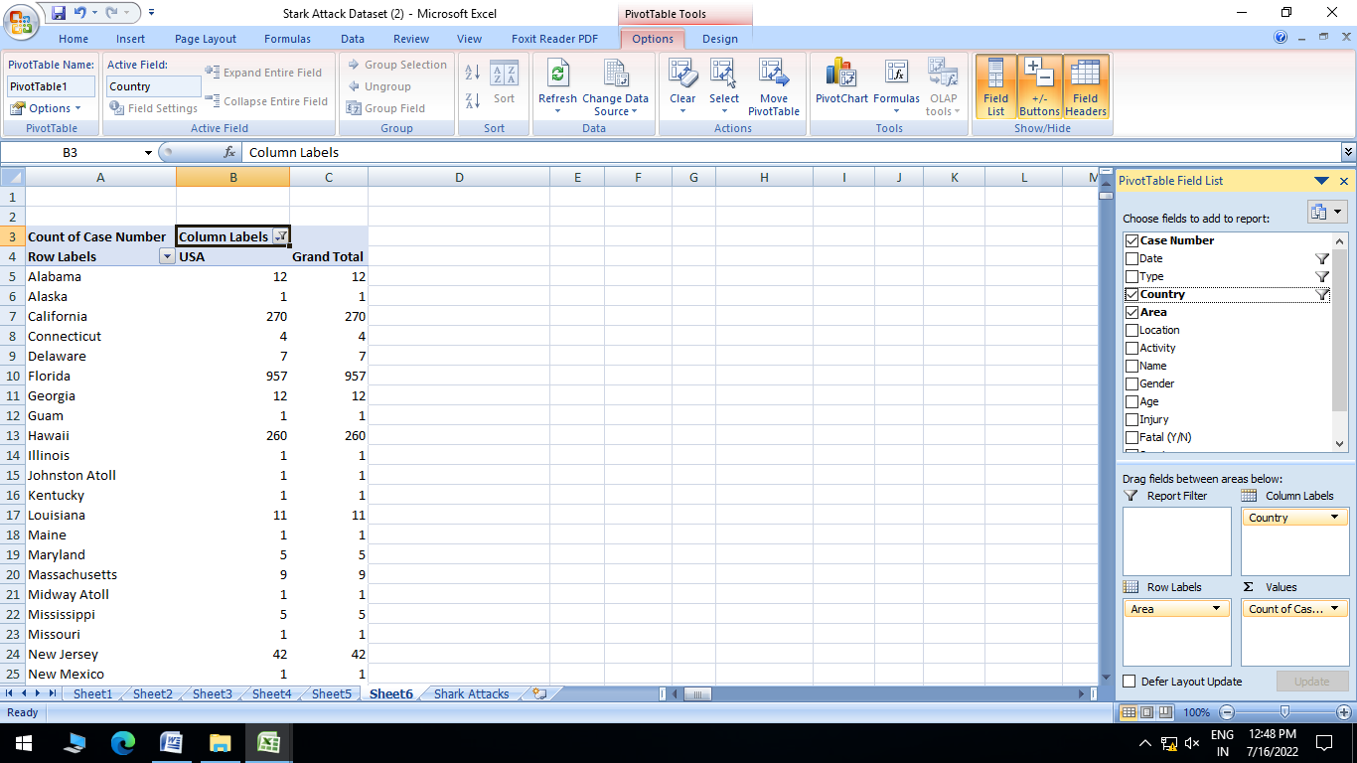

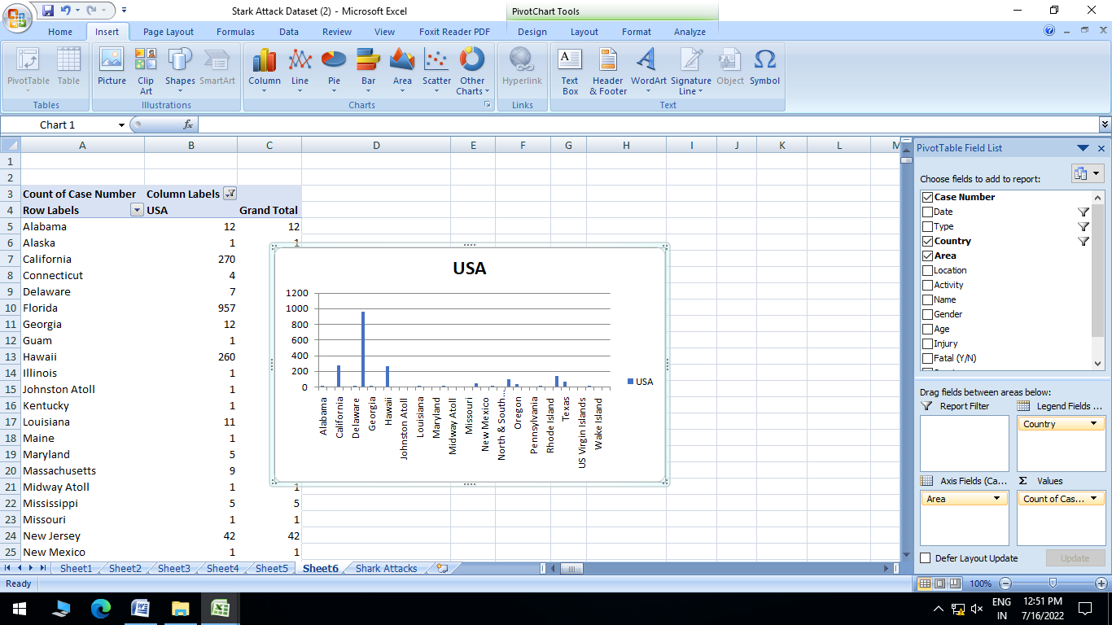

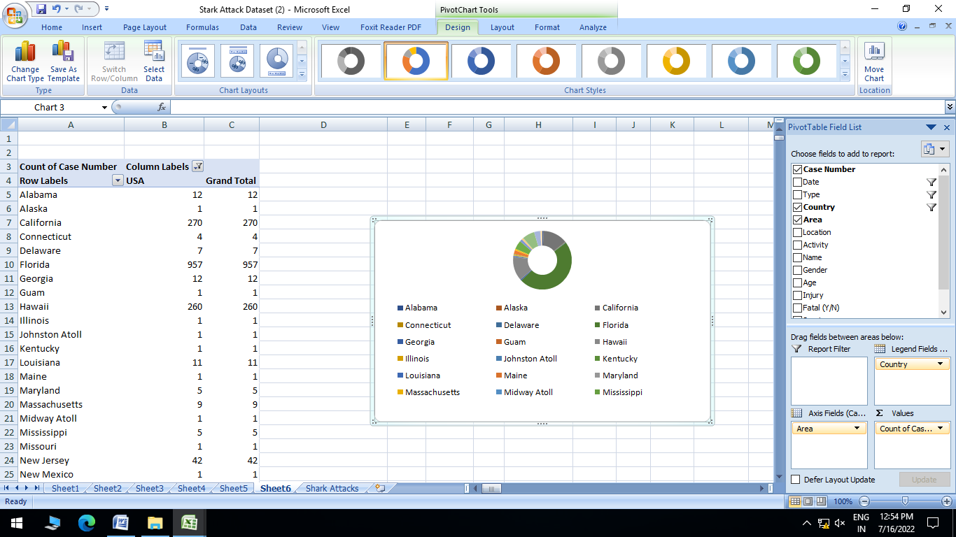

Q**5. What was Darren Good doing when he was attacked? When did this happen?**

